Given a 2D grid consists of 0s (land) and 1s (water).  An *island* is a maximal 4-directionally connected group of 0s and a *closed island* is an island **totally** (all left, top, right, bottom) surrounded by 1s.

Return the number of *closed islands*.

**Example 1:**

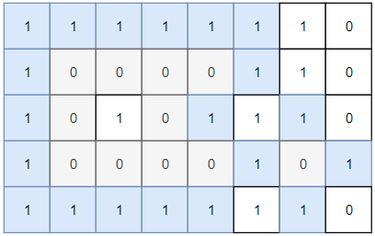

Input: grid = [[1,1,1,1,1,1,1,0],[1,0,0,0,0,1,1,0],[1,0,1,0,1,1,1,0],[1,0,0,0,0,1,0,1],[1,1,1,1,1,1,1,0]]  
Output: 2  
Explanation:   
Islands in gray are closed because they are completely surrounded by water (group of 1s).

**Example 2:**

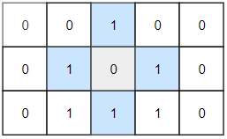

Input: grid = [[0,0,1,0,0],[0,1,0,1,0],[0,1,1,1,0]]  
Output: 1

**Example 3:**

Input: grid = [[1,1,1,1,1,1,1],  
  [1,0,0,0,0,0,1],  
  [1,0,1,1,1,0,1],  
  [1,0,1,0,1,0,1],  
  [1,0,1,1,1,0,1],  
  [1,0,0,0,0,0,1],  
 [1,1,1,1,1,1,1]]  
Output: 2

**Constraints:**

* 1 <= grid.length, grid[0].length <= 100
* 0 <= grid[i][j] <=1